Product specification

Customer |  | Annella | Customer Model | TN-1S8AT
Product Name |  | 1S 4A | Project Name | TN-1S8AT
Main configuration |  | 3.7v NMC Li-ion | Customer Material NO.
Controlled Revision |  | V0 | Issued Date | 2024/2/23
YUN YI
 |  |  | Client approval： □OK □NG
Prepared by/Date | 2024/2/23 |  | Checked by/ Date
QA Checked by/ Date |  |  | QA Checked by/ Date
Approved by / Date |  |  | Approved by / Date

1.History of revisions

Edition | Description | Prepared by | Date | Remarks
V0 | New | Lu Young | 2024/2/23

2. Product Specifications
2.1 Sphere of application
This specification is applicable to the 1-cell lithium-ion battery protection board developed and manufactured by SHEN ZHEN YUN YI TECHNOLOGY CO.,LTD，model TN-1S8AT

2.2 Environmental request

  - Functional description
1） Over-charge voltage protection
2） Over-discharge voltage protection
3） Over current protection
4） Short circuit protection
2.4 Mechanical characteristics
1） PCM size：L 50(±0.15mm)×W 7(±0.1mm)×T 3.5 mm(MAX)
2） PCB MATERIA/PCB: L：FR-4, 1.5 oz,1.0±0.1mm
3） LAYER：2Layers
4） Plating Method:：HASL-LF
5） PSR INK：Green,
6) SILK INK：White

2.5 Connecting description

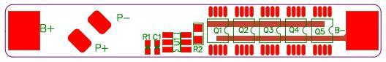

Symbol | Description | Symbol | Description
P+ | Battery output/charging positive pole | B+ | Cell positive pole
P- | Battery output/charging negative pole | B- | Cell negative pole

2.6 Electrical characteristic (Ta=25℃)
Contents | Min. | Type | Max. | Tolerance | Unit
Absolute Maximum Rating
Input Charging Voltage |  | 4.20 |  |  | V
Input Charging Current |  |  | 3 |  | A
Output Discharging Voltage | 2.90 | 3.70 | 4.28 |  | V
Continuous Output Discharging Current |  |  | 4 |  | A
Ambient Condition
Operating Temperature | -20 |  | +65 |  | ℃
Humidity (No Water-Drop) | 0% |  | 80% |  | RH
PCM Storage Condition/PCM
PCM Storage Temperature PCM | -55 |  | +125 |  | ℃
Humidity (No Water-Drop) | 45% |  | 85% |  | RH
Protection Parameters
Over-Charge Voltage Protection (OVP) | 4255 | 4280 | 4305 | ±25 | mV
Over-Charge Voltage Protection Release | 4030 | 4080 | 4130 | ±50 | mV
Over-Charge Voltage Protection Delay Time | 50 | 100 | 150 |  | mS
Over-Discharge Voltage Protection (UVP) | 2820 | 2900 | 2980 | ±80 | mV
Over-Discharge Voltage Protection Release | 2920 | 3000 | 3080 | ±80 | mV
Over-Discharge Voltage Protection Delay Time | 10 | 25 | 40 |  | mS
Over-Current Charge Protection Detection Voltage | -60 | -100 | -140 |  | mV
Over-Current Charge Protection (OCC) | 4 | 7 | 9 |  | A
Over-Current Charge Protection Delay Time | 7 | 12 | 20 |  | mS
Over-Current Discharge Protection Detection Voltage | 175 | 200 | 225 |  | mV
Over-Current Discharge Protection （OCD） | 10 | 15 | 20 |  | A
Over-Current Discharge Protection Delay Time | 5 | 10 | 20 |  | ms
Short Circuit ProtectionDetection voltage (SCP) | 550 | 850 | 1150 |  | mV
Short Circuit Protection Delay Time | 200 | 300 | 500 |  | uS
Short Circuit Protection Release | Remove Load Or Connect Charger
Current Consumption
Normal Mode |  | 3.0 | 6.0 |  | uA
Other Parameters
Impedance （B-&P-） | 5 | 25 | 50 |  | mΩ
Impedance （B+&P+） |  |  | 5 |  | mΩ
ID Resistor |  | / |  |  | KΩ
NTC Resistor |  | / |  |  | KΩ
0V Battery Charge Function | Available
ESD Protection Function ESD | no
4. SMT Diagram
Top layer

5.PCB Layout

Top layer | 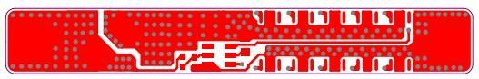
Top overlayer
Bottom layer | 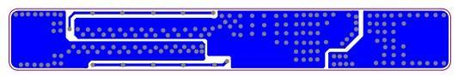
Bottom overlayer | 

6.Electrical Schematic

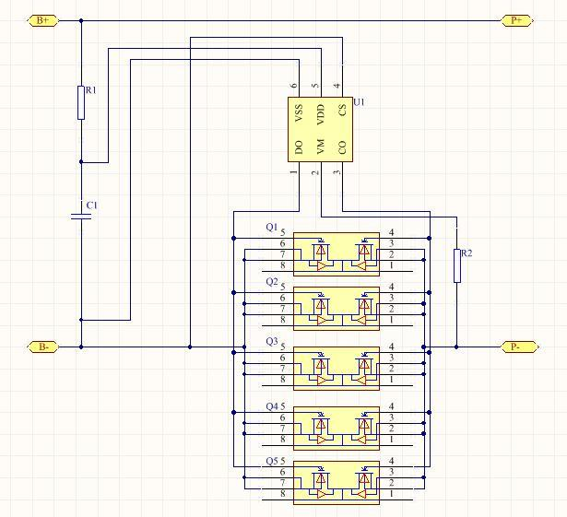

7.Special Requirements
NO.
1
2
3
8.PCB diagram / PCB

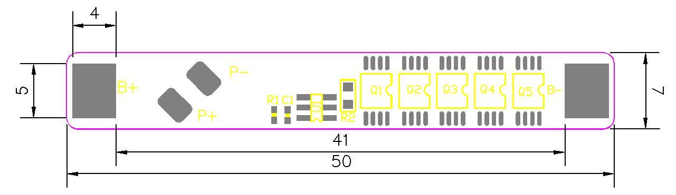
9.Packing、Storage And Transportation
9.1 Packing guide
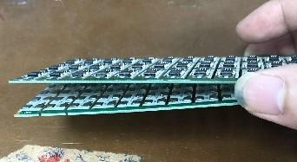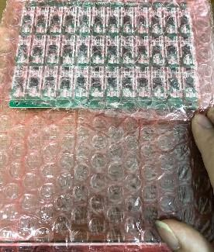
- 两片拼板背靠背叠整齐 ②用防静电气泡卷隔开包装
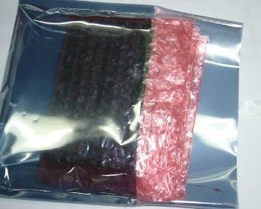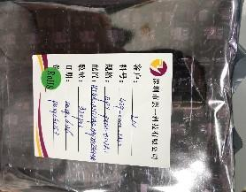
- 装入防静电袋 ④用胶布封口，贴标签
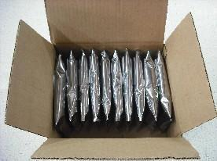
⑤连同产品合格证放入外箱内 ⑥外箱贴标签后封箱

9.2 Storage
9.2.1 Storage Temperature ：23±5℃
9.2.2 Storage Humidity ：45±15% RH
9.2.3 Should pay attention to ESD
9.3 Transportation
9.3.1 Delivery to your storhouse by express or our deliveryman.

9.3.2 Should pay attention to moisture, moisture, avoid extrusion, impact, etc., to prevent damage to the PCM during transportation.
10. Attachment
10.1 Sample test data

NO. | Test Project | Test standard | Tested Value |  |  |  |  | Judgement
NO. | Test Project | Test standard | 1 | 2 | 3 | 4 | 5 | Judgement
1 | Overcharge protection voltage | 4.28±0.25V |  |  |  |  |  | OK
2 | Overcharge protection delay time | MAX 150ms |  |  |  |  |  | OK
3 | Over discharge protection voltage | 2.90±0.80V |  |  |  |  |  | OK
4 | Over discharge protection delay time | MAX40ms |  |  |  |  |  | OK
5 | Discharge overcurrent protection current | 10-20A |  |  |  |  |  | OK
6 | Over current discharge protection delay time | MAX20ms |  |  |  |  |  | OK
7 | Static current | ≤6.0 uA |  |  |  |  |  | OK
8 | Impedance | ≤50mΩ |  |  |  |  |  | OK

10.2 Environmental Requirements
The specification subjects to the EU Directive about RoHS 2.0, and the hazardous substance conforms to the following standard.

Hazardous substance | Standard（mg/KG） | Remarks
Cd) | <100
(Pb) | <1000
(Hg) | <1000
(Cr6+) | <1000
(PBBs) | <1000
(PBDEs) | <1000
(DBP) | <1000
（BBP） | <1000
(DIBP) | <1000
）(DEHP) | <1000

Declaration: the above standard is the requirements of EU RoHS 2.0 Directive, we will base on the customer’s requirements when it is stricter than the EU standard.

